National University of Lesotho
Department of Mathematics and Computer Science
CS4433 Software Engineering, Final Individual Project
Moderated Learning Management System
Phase 2: Requirements Engineering
Hapile Manyeli | Student number 202002241 | 11 October 2026

4 Requirements engineering

4.1 Stakeholder analysis and conflict resolution
The brief gives five statements from different people, and they leave things out and some of them clash. Table 1 lists the stakeholders and what they want, Table 2 lists the conflicts and how I settled them, and Table 3 lists what the statements don't say and what I'm assuming. I'll check all of these with my supervisor at Gate 1.
Table 1: Stakeholders
Stakeholder | What they want
Principal | Easy enough for teachers who are not IT experts, and no student sees a mark before the HoD has checked it.
Lecturer | Marks reach students quickly, and a lecturer can give one student more time when there is a good reason.
Head of Department (HoD) | Late work loses 10% a day for 3 days and then gets zero, and the HoD sees every mark in the department before release.
Student representative | A student can fix a mistake and resubmit before the deadline, gets written feedback, and late work is not simply refused.
IT officer | Works offline on old computers, passwords are protected, and it is still fast with all 800 students on it.
Administrator | Not in the five statements but the system needs one. Sets up users, departments, courses, lecturers and enrolment.

Table 2: Conflicts and how I resolved them
ID | Conflict | Resolution
C1 | The lecturer wants marks released as soon as they are marked. The principal says the HoD must check them first. | A mark has three states, marked, moderated and released. Students only see released marks. The principal's rule holds and the lecturer still gets marks out as fast as moderation allows.
C2 | The student representative says late work should not just be refused. The HoD says it gets zero after 3 days. | Late work is always accepted and flagged as late. The HoD's penalty stays exactly as stated, and the mark only becomes zero after 3 days.
C3 | Only the lecturer mentions extensions, and nobody says what a good reason is. | The lecturer gives one student a new deadline and writes a reason. I'm not putting rules about reasons in the software because that's the school's decision. A class-wide extension is left for a later change request.
C4 | Students can resubmit before the deadline, but not how many times or what happens to the old copy. | Unlimited resubmissions before the deadline and only the latest is kept. After the deadline a student with no submission can submit once.
C5 | The IT officer wants it offline, but the brief says local network and SQLite is not safe on a network share. | The database sits on one computer and everyone uses that computer, which I'll confirm at Gate 1.
C6 | The HoD must see every mark, and the school also wants to know who changed a mark. | Moderation is a list of every marked submission in the department. Approve, adjust and return all go in the audit log, and adjust and return need a reason.

Table 3: Ambiguities and what I assumed
ID | Question | What I assumed
A1 | How is a day late counted? | Every started 24 hours after the deadline is one day.
A2 | Is 10% of the maximum mark or of the mark given? | Of the maximum mark.
A3 | Can an extension be given after the deadline? | Yes, until that student's work has been marked.
A4 | Does the HoD moderate other departments or their own marks? | No to both. The administrator arranges another HoD for a HoD's own marks.
A5 | Can a course sit in two departments or have no lecturer? | One department and at least one lecturer.

4.2 Software requirements specification
This follows the usual SRS layout of an introduction, an overall description and then the specific requirements. Every requirement has its own ID and a MoSCoW priority and can be tested, so each one can get a test case in Phase 5.

4.2.1 Introduction
The system lets a secondary school run courses, assignments and marking for four roles, administrator, lecturer, Head of Department and student. It covers accounts, courses and enrolment, assignments, submission and resubmission, late penalties, extensions, marking with feedback, moderation by the HoD before release, and an audit log of mark changes. Payments, video, automated grading, plagiarism checks and web or mobile apps are out of scope.

4.2.2 Overall description
It is a C++17 console program with a SQLite database on one school computer. Each role only sees the menu items it can use, because the teachers are not IT experts. It has to work offline on old computers. The data is personal and many learners are minors, so the Data Protection Act applies. I am assuming about 800 students, 8 courses each and 64,000 submissions a year, as in the project plan.

4.2.3 Functional requirements
Table 4: Functional requirements
ID | Requirement | Priority
FR-01 | The system shall ask for a username and password, and lock an account after 5 failed attempts until an administrator resets it. | Must
FR-02 | The system shall check the user's role before every action and refuse anything the role is not allowed to do. | Must
FR-03 | A user shall be able to change their own password. | Should
FR-04 | The administrator shall be able to create, edit, deactivate and reset user accounts. | Must
FR-05 | The administrator shall be able to create and edit departments and courses, and each course belongs to one department. | Must
FR-06 | The administrator shall be able to assign lecturers to courses and enrol students. | Must
FR-07 | A lecturer shall be able to create an assignment with a title, deadline and maximum mark. | Must
FR-08 | A lecturer shall be able to give one student a later deadline with a reason, and the system shall use it from then on. | Must
FR-09 | A student shall be able to submit work before or after the deadline, and late work is flagged as late. | Must
FR-10 | A student shall be able to resubmit before the deadline and only the latest version is kept. | Must
FR-11 | The system shall work out the final mark from the raw mark using the late penalty in BR1. | Must
FR-12 | A lecturer shall be able to enter a mark and written feedback for a submission. | Must
FR-13 | A lecturer shall be able to change a mark that has not been approved, and the old value is kept. | Must
FR-14 | The HoD shall be able to list every marked submission in their department that is not released. | Must
FR-15 | The HoD shall be able to approve a mark, adjust it with a reason, or return it for re-marking. | Must
FR-16 | The HoD shall be able to release approved marks, and the system refuses to release one that is not approved. | Must
FR-17 | A student shall only see marks and feedback that have been released. | Must
FR-18 | A student shall be able to list their courses and assignments with deadlines and status. | Must
FR-19 | The system shall write an audit entry for every mark entry, change, adjustment, return and release, with who, when, old and new value and reason. | Must
FR-20 | The administrator shall be able to view the audit log. | Must
FR-21 | The administrator shall be able to export the audit log to a text file. | Should
FR-22 | The administrator shall be able to back up and restore the database. | Should
FR-23 | The HoD shall be able to export department marks to a CSV file. | Could
FR-24 | Extending a deadline for a whole class. Left out of v1.0 and kept as a change request. | Won't
FR-25 | Notifying students when marks are released. Left out of v1.0 because it needs a network. | Won't

That is 25 functional requirements, 19 Must, 3 Should, 1 Could and 2 Won't.

4.2.4 Non-functional requirements
Table 5: Non-functional requirements
ID | Requirement | How it is checked | Priority
NFR-01 | With 800 students and 64,000 submissions loaded, login takes at most 2 seconds and every other menu action at most 1 second. | Timed test on a generated database, 20 runs. | Must
NFR-02 | The system runs with no network connection and makes no network calls. | Run with the network off. | Must
NFR-03 | Passwords are stored only as salted hashes. | Look at the users table after a test run. | Must
NFR-04 | Every SQL statement that uses user input is parameterised. | Code search, plus 10 injection strings that change no data. | Must
NFR-05 | Invalid input never crashes the system and never changes data. | 30 invalid inputs, 0 crashes, 0 data changes. | Must
NFR-06 | Nobody can edit or delete an audit entry, and it is written in the same transaction as the change. | Try to change one from every menu, and force a failure halfway. | Must
NFR-07 | Any task takes at most 4 menu selections, and each menu only shows what the role can use. | Count the selections for each use case. | Must
NFR-08 | Each function has a cyclomatic complexity of at most 10 and unit test line coverage is at least 70%. | cppcheck report and coverage report from the CI run. | Must
NFR-09 | The code builds with GCC 9 or later and Clang 10 or later, and a technician can install it in 30 minutes. | CI build with both compilers, and I time someone using the install guide. | Must
NFR-10 | Only data the process needs is kept, and the administrator can delete a leaver's personal data and keep their marks anonymous, in line with Lesotho's Data Protection Act. | Check the tables against what each is for, and run the deletion on test data. | Must
NFR-11 | The database holds 320,000 submissions (5 years at 64,000 a year) and still meets NFR-01. | Repeat the NFR-01 test on a database that size. | Must
NFR-12 | Output is plain text that a screen reader can read, and colour is never the only way information is shown. | Read the main menus aloud, and check them with colour off. | Should

4.2.5 Business rules
BR1, late penalty. Days late is the hours late divided by 24, rounded up. Each day late loses 10% of the maximum mark, up to 3 days, and more than 3 days gives zero. The final mark is the raw mark minus the penalty and never goes below 0. One second late is 1 day, exactly 24 hours late is 1 day, 24 hours and 1 second is 2 days, 72 hours is 3 days and 72 hours and 1 second is zero. For example, with a maximum of 20, a raw mark of 15 and 30 hours late, that is 2 days, a penalty of 4 and a final mark of 11.
BR2, resubmission. Before the effective deadline a student can resubmit as often as they like and only the latest is kept. After it, a student with no submission can submit once and nothing can change after that. The effective deadline is the lecturer's extension for that student if there is one, otherwise the assignment deadline.
BR3, moderation. A mark can only be released after the HoD has approved or adjusted it.
BR4, extensions. Only the lecturer of the course can give one, for one student at a time, with a reason, until that student's work is marked.
BR5, audit. Every change to a mark writes an audit entry in the same transaction, and nobody can edit or delete an entry.

4.3 Use case model
Figure 1 is the use case diagram for the four actors. Each use case has the number of the functional requirement it covers. A dotted arrow marked include means the use case always runs the other one, and one marked extend means it only runs in some cases. Moderate marks includes Approve, Adjust and Return. I wrote out three of them in full, Submit assignment, Moderate marks and Grant extension.
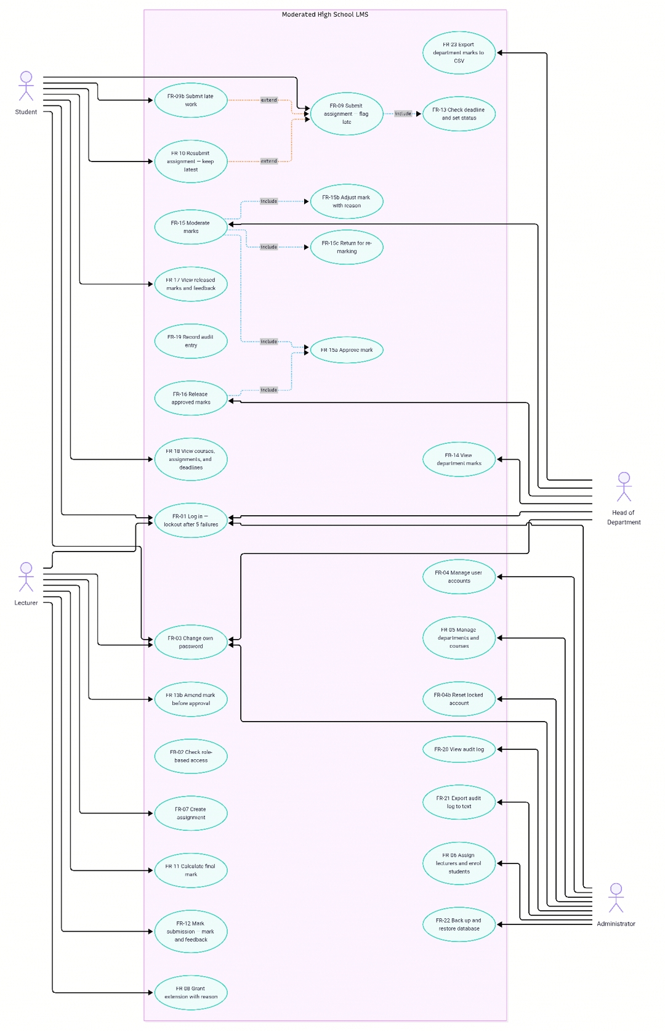
Figure 1: Moderated High School LMS use case diagram

4.3.1 Submit assignment
Actor | Student
Preconditions | The student is logged in and enrolled in the course, and the assignment exists.
Main flow | 1. The student chooses Submit assignment and picks a course.  2. The system lists the assignments with their deadlines.  3. The student picks one.  4. The system checks the deadline (including any extension) and sets the status to Submitted.  5. The student enters the work.  6. The system checks the input is not empty and not too big.  7. The system stores the submission with the time and status in one transaction.  8. The system shows a confirmation.
Alternative flows | 3a. The student already has a submission and the deadline has not passed. The system asks if they want to replace it. If yes it carries on from step 5, if no it ends.  3b. The deadline has passed and there is no submission. The system warns that it will be marked late with a penalty. If the student agrees it carries on from step 5 and the status is Late.  3c. The lecturer has given this student an extension. Step 4 uses the extended deadline.
Exception flows | 2a. The student has no courses or the course has no assignments. The system says so and ends.  3d. The deadline has passed and the student already has a submission. The system refuses and ends.  6a. The input is empty or too big. The system says why and asks again.  7a. The database write fails. Nothing is saved, the student is told to try again and the error is logged.
Postconditions | Success, one submission is stored with its time and status. Failure, nothing changes.
Business rules | BR1, BR2, BR4

4.3.2 Moderate marks
Actor | Head of Department
Includes | Approve mark, Adjust mark and Return for re-marking, as in Figure 1.
Preconditions | The HoD is logged in and there is at least one marked submission in their department.
Main flow | 1. The HoD chooses Moderate marks.  2. The system lists every marked submission in the department that is not released, with raw mark, penalty and final mark.  3. The HoD picks one and reads the mark and feedback.  4. The HoD chooses Approve.  5. The system sets the state to Moderated and writes the audit entry in the same transaction.  6. The system shows a confirmation and goes back to the list.
Alternative flows | 4a. The HoD chooses Adjust. The system asks for a new mark between 0 and the maximum and a reason, stores them, sets the state to Moderated and writes an audit entry with the old and new marks. Carries on at step 6.  4b. The HoD chooses Return. The system asks for a reason, sets the state to Returned and writes an audit entry. The lecturer re-marks and the submission comes back to the list. Carries on at step 6.
Exception flows | 2a. Nothing is waiting. The system says so and ends.  4c. The submission is from another department or the HoD entered the mark. The system refuses and goes back to the list.  4d. The reason for Adjust or Return is empty. The system asks again.  5a. The database write fails. Everything rolls back and the HoD is told to try again.
Postconditions | Success, the mark is Moderated or Returned and an audit entry exists. Failure, nothing changes.
Business rules | BR3, BR5
Releasing is a separate use case, Release approved marks. The HoD picks Moderated marks and the system sets them to Released, writes an audit entry for each, and from then on the student can see them.

4.3.3 Grant extension
Actor | Lecturer
Preconditions | The lecturer is logged in and teaches the course, the assignment exists and the student is enrolled.
Main flow | 1. The lecturer chooses Grant extension and picks a course.  2. The system lists the assignments.  3. The lecturer picks one.  4. The system lists the enrolled students with their current deadline.  5. The lecturer picks a student.  6. The system asks for the new deadline and a reason.  7. The lecturer enters them.  8. The system checks the new deadline is later than the current one, stores it with the reason and writes an audit entry in one transaction.  9. The system shows a confirmation.
Alternative flows | 5a. The student already has an extension. The system shows it and asks if it should be replaced. If not, it ends.
Exception flows | 5b. The student's work is already marked. The system refuses and ends.  7a. The deadline is not later than the current one or is not a date. The system says why and asks again.  7b. The reason is empty. The system asks again.  8a. The database write fails. Nothing changes and the lecturer is told to try again.
Postconditions | Success, the student has a new deadline and an audit entry exists. Failure, nothing changes.
Business rules | BR4

